PROJECT PLANNING PHASE
Project Planning Template – Blog Nest
Date: 24 September 2026
Team ID | SWTID-2026-9317
Project Name | Blog Nest
Maximum Marks | 5 Marks

1. Product Backlog, Sprint Schedule, and Estimation
The following backlog and sprint schedule are prepared for Blog Nest, a blog-management application where users can create accounts, publish posts, browse content, and manage their profiles.
Sprint | Functional Requirement (Epic) | User Story No. | User Story / Task | Story Points | Priority | Team Members
Sprint-1 | Registration | USN-1 | As a user, I can register for Blog Nest using my email and password. | 2 | High | Team Members
Sprint-1 | Registration | USN-2 | As a user, I can receive confirmation after successful registration. | 1 | High | Team Members
Sprint-1 | Login | USN-3 | As a user, I can log in using my registered email and password. | 1 | High | Team Members
Sprint-1 | Profile | USN-4 | As a user, I can view and update my profile information. | 2 | Medium | Team Members
Sprint-2 | Blog Management | USN-5 | As a user, I can create and save a new blog post. | 3 | High | Team Members
Sprint-2 | Blog Management | USN-6 | As a user, I can edit and delete my own blog posts. | 3 | High | Team Members
Sprint-2 | Blog Management | USN-7 | As a user, I can add an image to a blog post. | 2 | Medium | Team Members
Sprint-3 | Blog Discovery | USN-8 | As a user, I can browse published blog posts. | 2 | High | Team Members
Sprint-3 | Blog Discovery | USN-9 | As a user, I can search for blog posts by title or keyword. | 3 | Medium | Team Members
Sprint-3 | Interaction | USN-10 | As a user, I can like and comment on a published post. | 3 | Medium | Team Members
Sprint-4 | Dashboard | USN-11 | As a user, I can view my posts and basic activity from a dashboard. | 2 | High | Team Members
Sprint-4 | Administration | USN-12 | As an administrator, I can manage users and inappropriate posts. | 3 | Medium | Team Members

2. Sprint Schedule and Project Tracker
Sprint | Sprint Total Story Points | Duration | Sprint Start Date | Sprint End Date (Planned) | Story Points Completed | Sprint Release Date (Actual)
Sprint-1 | 6 | 6 Days | 24 Sep 2026 | 29 Sep 2026 | — | —
Sprint-2 | 8 | 6 Days | 30 Sep 2026 | 05 Oct 2026 | — | —
Sprint-3 | 8 | 6 Days | 06 Oct 2026 | 11 Oct 2026 | — | —
Sprint-4 | 5 | 6 Days | 12 Oct 2026 | 17 Oct 2026 | — | —

3. Blog Nest System Overview
Blog Nest is planned as a simple blog platform. The main workflow is: Register/Login → Dashboard → Create/Edit Blog → Add Images → Publish → Browse/Search → Like/Comment → Manage Content.
REGISTER / LOGIN | DASHBOARD | CREATE POST | ADD IMAGE | PUBLISH | SEARCH / READ | LIKE / COMMENT

4. Suggested Blog Nest UI Images
The following visual references illustrate the main screens that can be included in the documentation. Replace them with screenshots of the actual Blog Nest application when available.
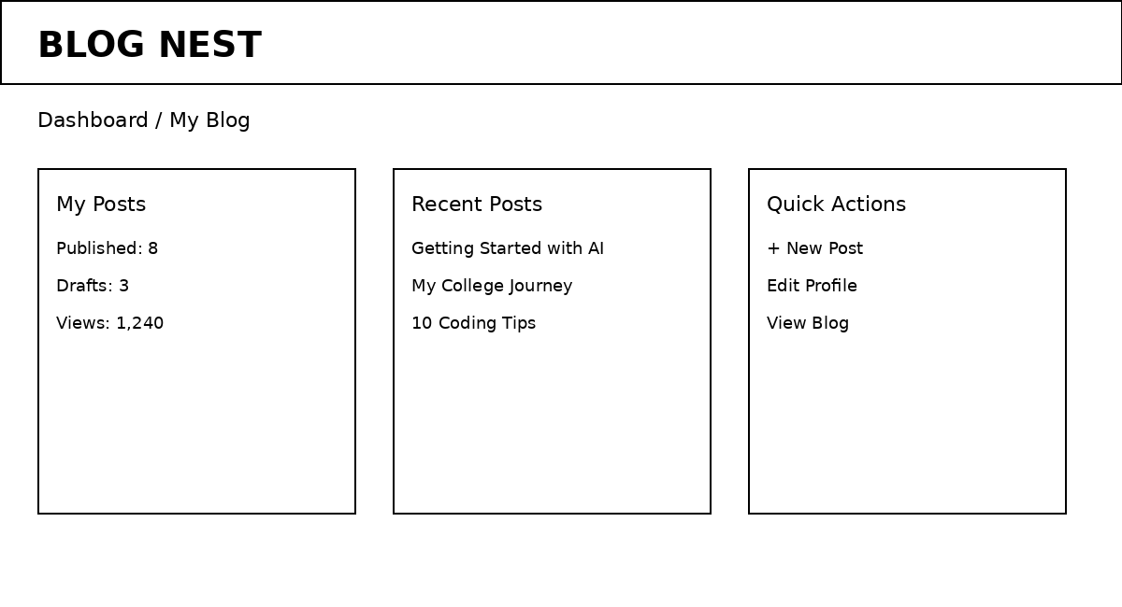
Figure 1. Blog Nest dashboard mock-up.
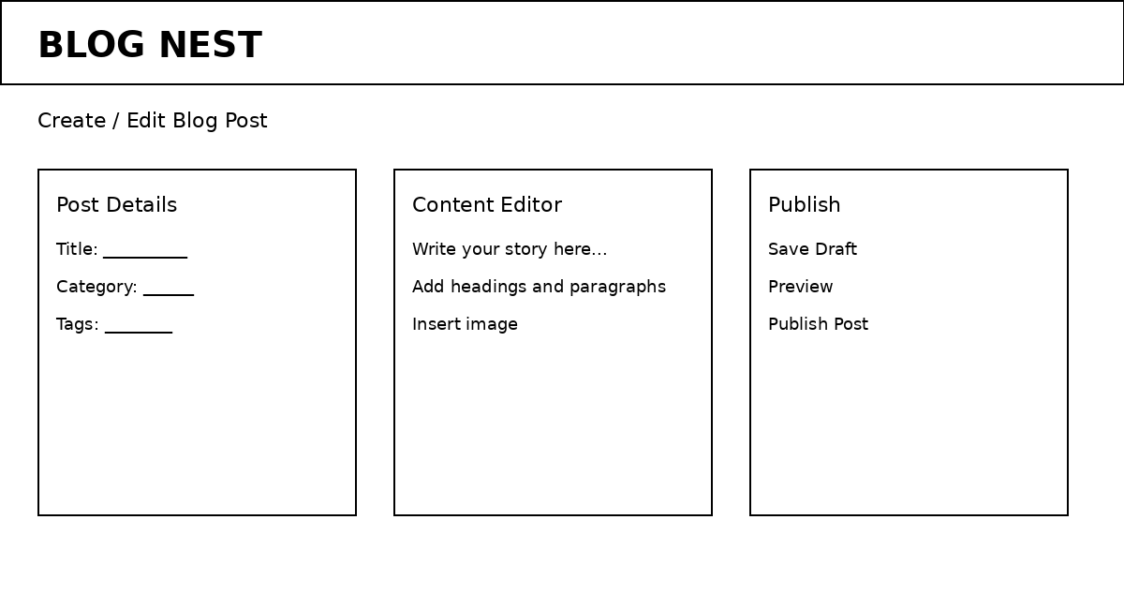
Figure 2. Blog Nest blog editor mock-up.

5. Velocity
For planning purposes, if a team completes 20 story points in a 10-day sprint, the average velocity per iteration day is 20 ÷ 10 = 2 story points/day. Actual Blog Nest velocity should be calculated from completed story points after each sprint.

6. Burndown Chart
A burndown chart shows the amount of work remaining against time. For Blog Nest, the chart can track the remaining story points during each sprint and help the team identify whether planned work is progressing toward the sprint end date.
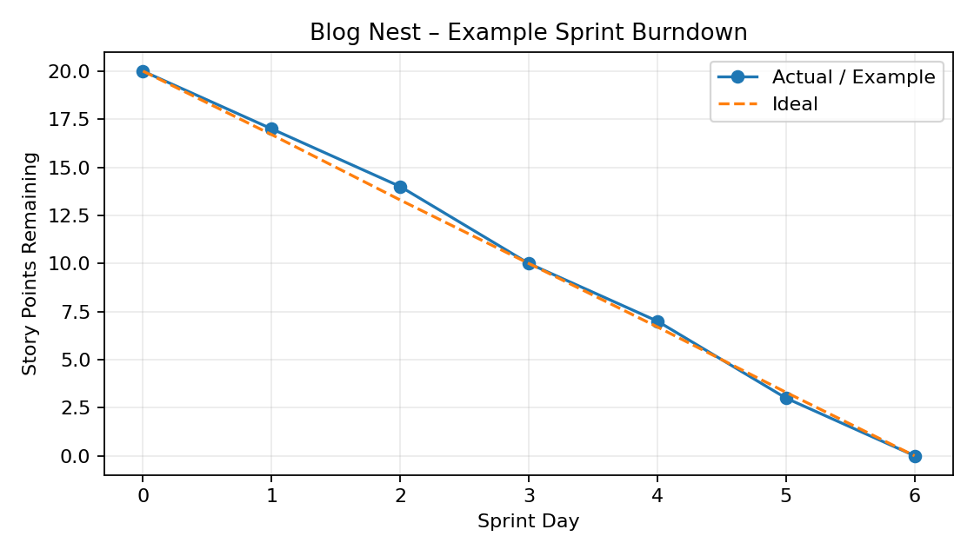
Figure 3. Example Blog Nest sprint burndown chart.

7. References
https://www.atlassian.com/agile/project-management
https://www.atlassian.com/agile/tutorials/how-to-do-scrum-with-jira-software
https://www.atlassian.com/agile/tutorials/epics
https://www.atlassian.com/agile/tutorials/sprints
https://www.atlassian.com/agile/project-management/estimation
https://www.atlassian.com/agile/tutorials/burndown-charts

